NST21022 - Practical for Network Switching and Routing

Department of Information and Communication Technology
Faculty of Technology
Lab sheet :02
Reg. Number: SEU/IS/20/ICT/084
Academic Year :2020/2021
Practical No :02

Title:
- Basic Switch and End Device Configuration
Aims:
  - Get familiar with IOS command structure
  - Get familiar with basic nodes (Device) configuration

Tasks:
  - Set Up the Network Topology
  - Configure PC Hosts
  - Configure and Verify Basic Switch Settings

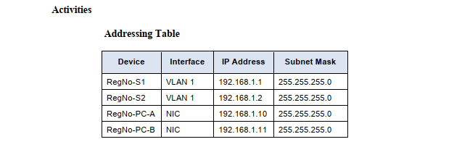
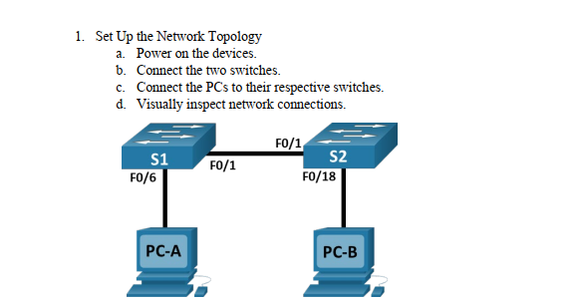
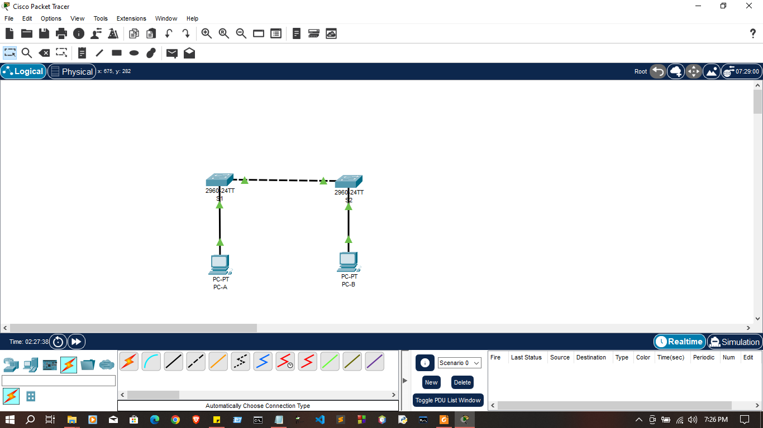

2. Configure PC Hosts
  - Configure static IP address information on the PCs according to the Addressing Table.
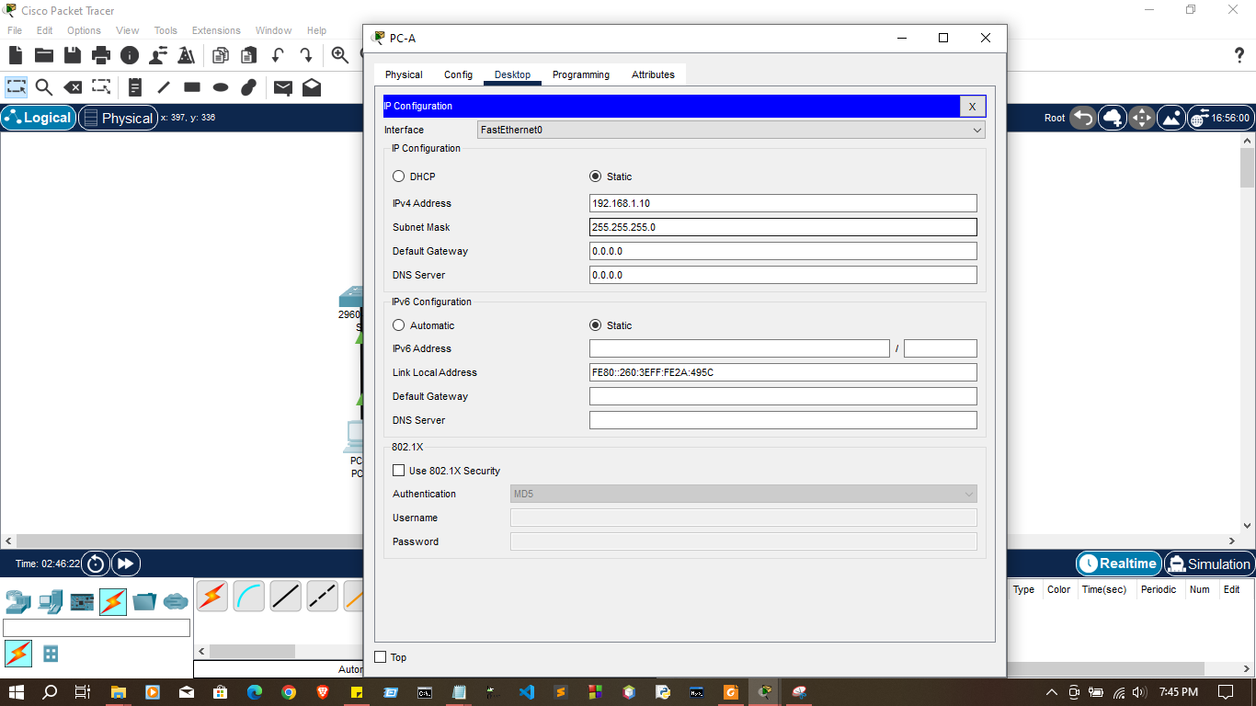
  - Verify PC settings and connectivity
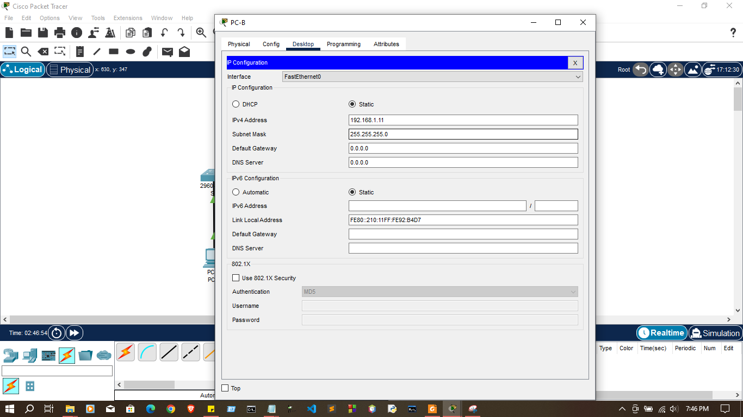

03.Configure and Verify Basic Switch Settings

a. Console into the switch. Enter the global configuration mode.
Switch>enable Switch#

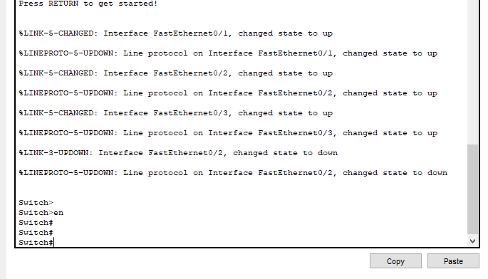

  - Go global configure mode - command:
configure terminal

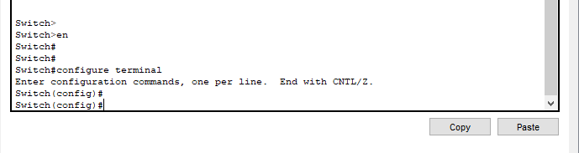

c. Give the switch a name according to the Addressing Table.
Switch#configure terminal
Switch(config)#hostname RegNo-S1
S1(config)#

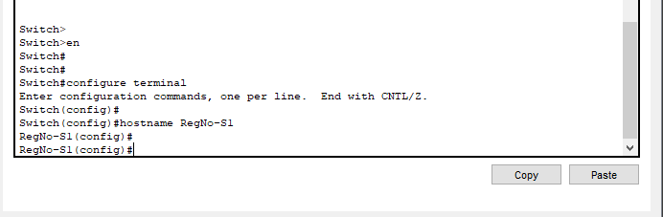

d. Prevent unwanted DNS lookups.
Switch(config)#no ip domain-lookup

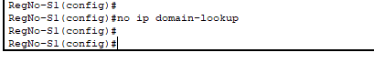

e.Configure password for console access

f. enter line console configuration mode command: line console 0

(The zero is used to represent the first (and in most cases the only) console interface)

g. Set password for CLI command:
S1#configure terminal
S1(config)#line console 0
S1(config-line)#password 1234
S1(config-line)#login
S1(config-line)#end

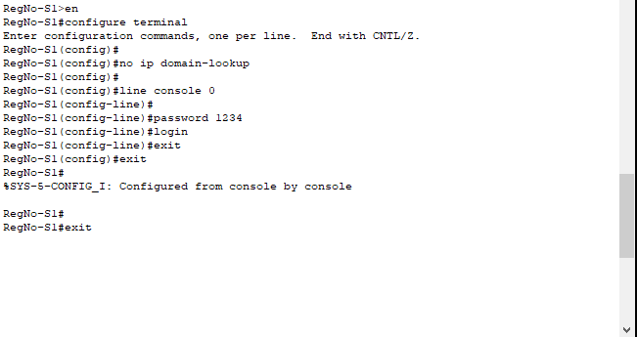

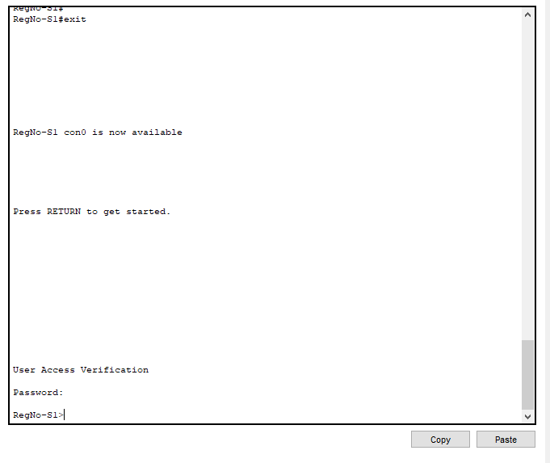
h. Use class as the privileged EXEC password
S1(config)#enable secret class
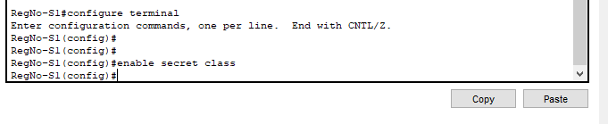

i. Encrypt the password
S1#configure terminal
S1(config)#service password-encryption
S1(config)#
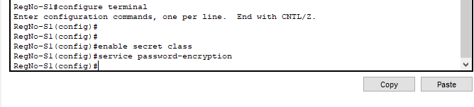
j. Configure and enable the Switch Virtual Interface according to the
Addressing Table.
S1(config)# interface vlan 1
S1(config-if)# ip address 192.168.1.1 255.255.255.0 S1
(config-if)# no shutdown
%LINEPROTO-5-UPDOWN: Line protocol on Interface Vlan1, changed state to up
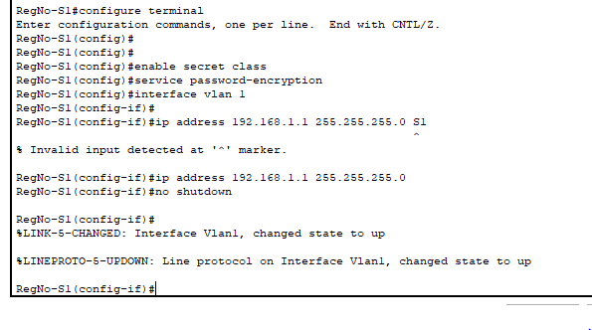

k. Configure Banner Messages
S1#configure terminal
S1(config)#banner motd #Authorized Access Only#
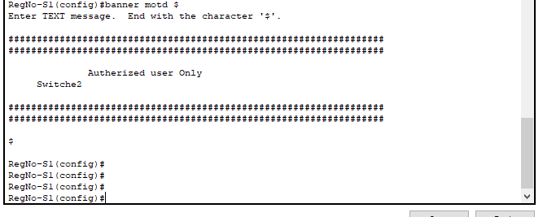

l. Verify all configuration
S1#show running-config

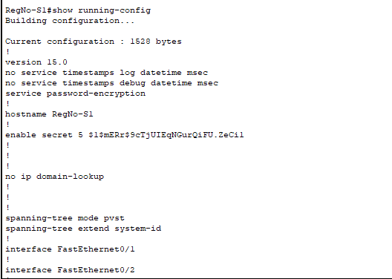

m. Save configuration
S1>enable
S1#copy running-config
startup-config Destination filname [startup- config]?
Building configuration...
[OK]
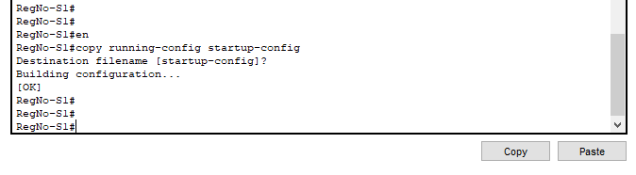

Output:-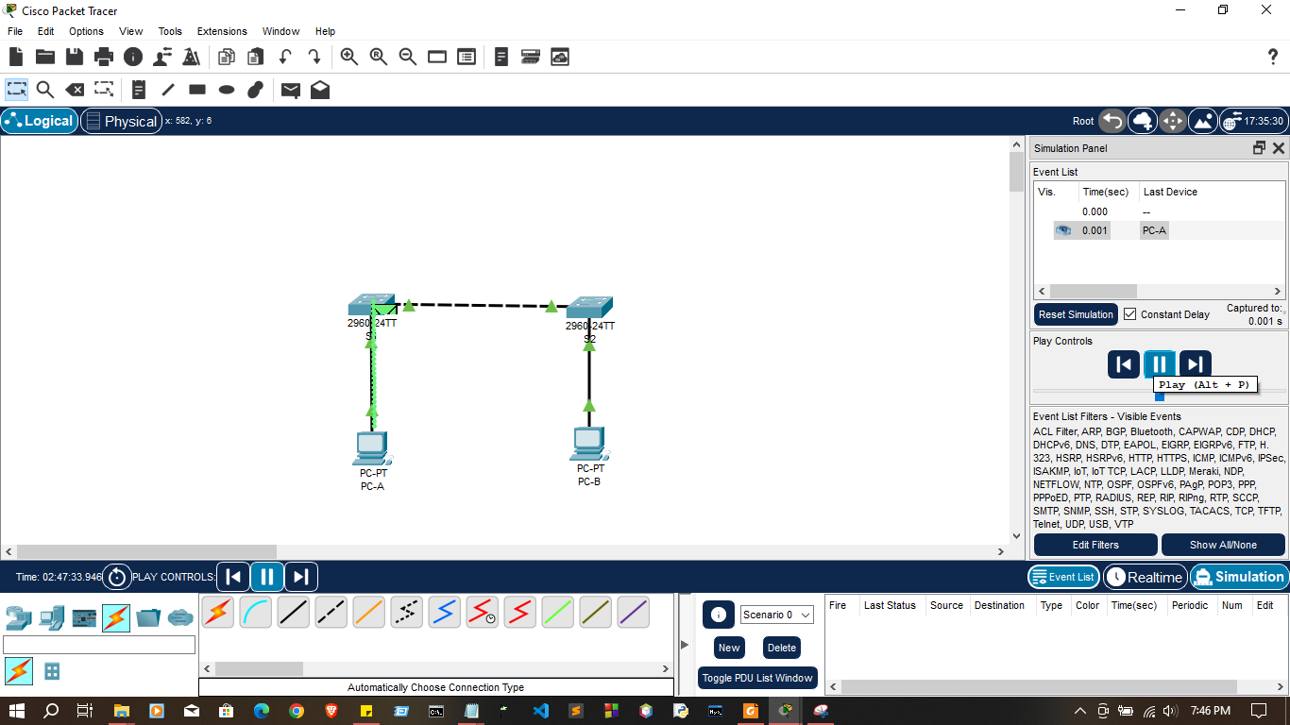
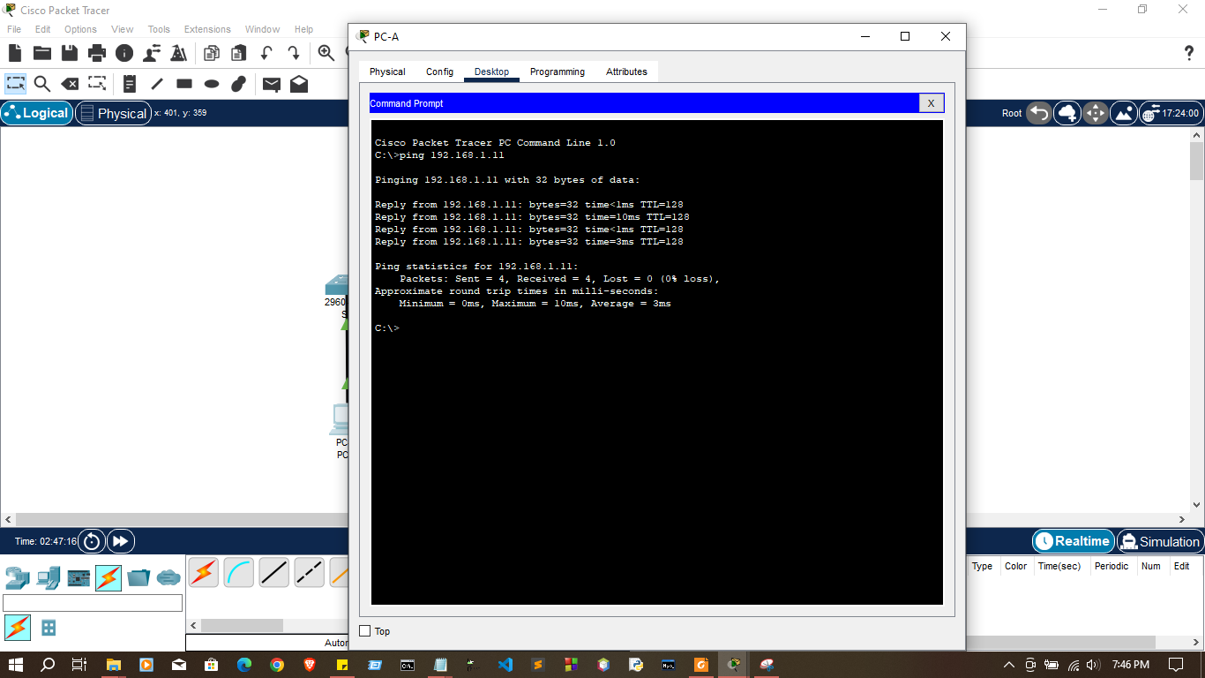

Discussion
- the discussion outlined the essential steps in setting up a network topology, configuring PC hosts, and ensuring basic switch settings within Cisco Packet Tracer. These fundamental actions are crucial for creating a functional and well-organized network. The main points covered include:
- Network Topology Setup:
- The initial step involves placing devices such as PCs and switches in the Packet Tracer workspace and establishing connections using appropriate cables. The spatial arrangement and connections determine the overall network design.
2.Configuring PC Hosts:
- The configuration of PC hosts is a critical aspect of network setup. This includes assigning unique IP addresses, configuring subnet masks, setting default gateways, and specifying DNS settings. Proper PC configuration ensures seamless communication within the network and external access.
3.Configuring and Verifying Switch Settings:
- Switches play a vital role in local network connectivity. Basic switch configuration includes assigning a hostname, setting passwords for security, and configuring interfaces. VLAN configuration may also be necessary for logical network segmentation. Verification steps, such as checking configurations and interface status, are essential.
4.Discussion Emphasis:
- The discussion emphasized the significance of IP configuration on PC hosts, including the importance of unique addresses and subnetting for efficient resource allocation. It also highlighted the role of switch configuration in enhancing network security and management. Verification steps and considerations for troubleshooting were discussed to ensure the network operates as intended.
5.Summary of Troubleshooting Considerations:
- The discussion acknowledged potential issues during the configuration process, such as IP conflicts or misconfigurations. It stressed the importance of troubleshooting steps, encouraging learners to use commands like ipconfig on PCs and show running-config on switches to identify and address issues.

This comprehensive approach to network setup and configuration in Cisco Packet Tracer provides learners with valuable hands-on experience, essential for developing practical skills in networking. The emphasis on verification and troubleshooting enhances the understanding of network functionality and problem-solving in real-world scenarios.

Thank you..

